**TABLEAU PROJECT HR DASHBOARD**

1. OBJECTIVE :

To create a comprehensive dashboard to analyze human resources data, providing both summary views for high-level insights and detailed employee records for in-depth analysis.

2. PROBLEM STATEMENT :

The HR department lacks a centralized system to access and analyze workforce data effectively. Key insights such as employee hiring and termination trends, workforce distribution by department, location, demographics, and salary comparisons are not readily available. This makes it difficult to track workforce changes, assess diversity, ensure pay equity, and evaluate performance. Additionally, the absence of a structured and filterable employee records view limits detailed analysis at the individual level. These gaps highlight the need for a comprehensive HR dashboard that provides both summary insights and detailed employee information.

3. DATASET :

The data used in this HR Dashboard project is generated using a combination of ChatGPT prompts and the Python [Faker library](https://fakerjs.dev/).

The uploaded dataset contains detailed employee data, structured with the following columns:

* Employee_ID
* First Name
* Last Name
* Gender
* State
* City
* Education Level
* Birthdate
* Hiredate
* Termdate
* Department
* Job Title
* Salary
* Performance Rating

The dataset is semicolon-separated and appears to have extensive records for employees across various states and job roles, including hire and termination dates along with salary and performance ratings.

SUMMARY INSIGHTS :

## Overview

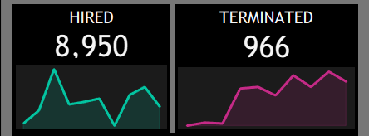

* The company has 7,984 active employees currently. Over the period, 8,950 employees were hired while 966 were terminated, indicating a net positive growth in the workforce. The hiring trend shows fluctuations but remains generally strong, while terminations have gradually increased.

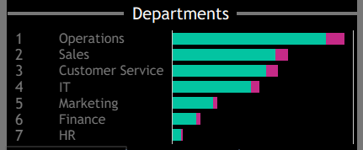

* The Operations department is the largest, followed by Sales and Customer Service, which suggests these are the key operational areas driving the business. Other departments including IT, Marketing, Finance, and HR have smaller teams, indicating focused support functions.

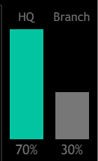

* Geographically, 70% of employees are based in the headquarters, with 30% in branch locations. The major employment hubs include New York, Pennsylvania, West Virginia, and North Carolina.

## Demographics

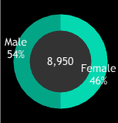

* The workforce consists of 54% males and 46% females, showing balanced gender representation.

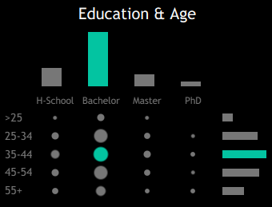

* Most employees hold a Bachelor's degree, especially those in the 35-44 age group, representing a mature and educated talent pool. High School, Master’s, and PhD holders represent smaller proportions.

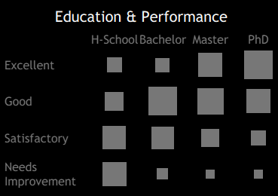

* Performance across education levels indicates that employees with advanced degrees (Master’s and PhDs) tend to be rated Excellent, while other education groups span from Satisfactory to Needs Improvement.

## Income

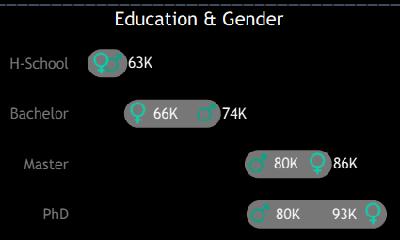

* Salary generally increases with educational attainment: High School graduates earn around 63K, Bachelor’s degree holders 66K (female) and 74K (male), Master’s degree holders earn 80K (male) and 86K (female), with PhDs earning the highest at 80K (male) and 93K (female).
* Interestingly, females tend to earn more than males at higher education levels, signaling a positive trend toward gender pay equity.

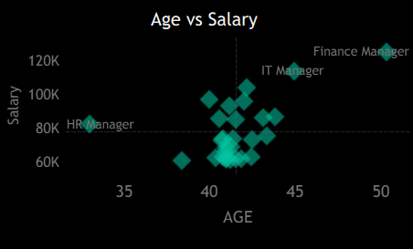

* In terms of age and salary relationship, roles like Finance Manager and IT Manager command the highest salaries, with ages mostly between 40-50. The HR Manager holds a lower salary, around 80K but with comparable age range to other managers, highlighting salary differences by department and role.

HR|DETAILS DASHBOARD

## **Employee Records & Filters**

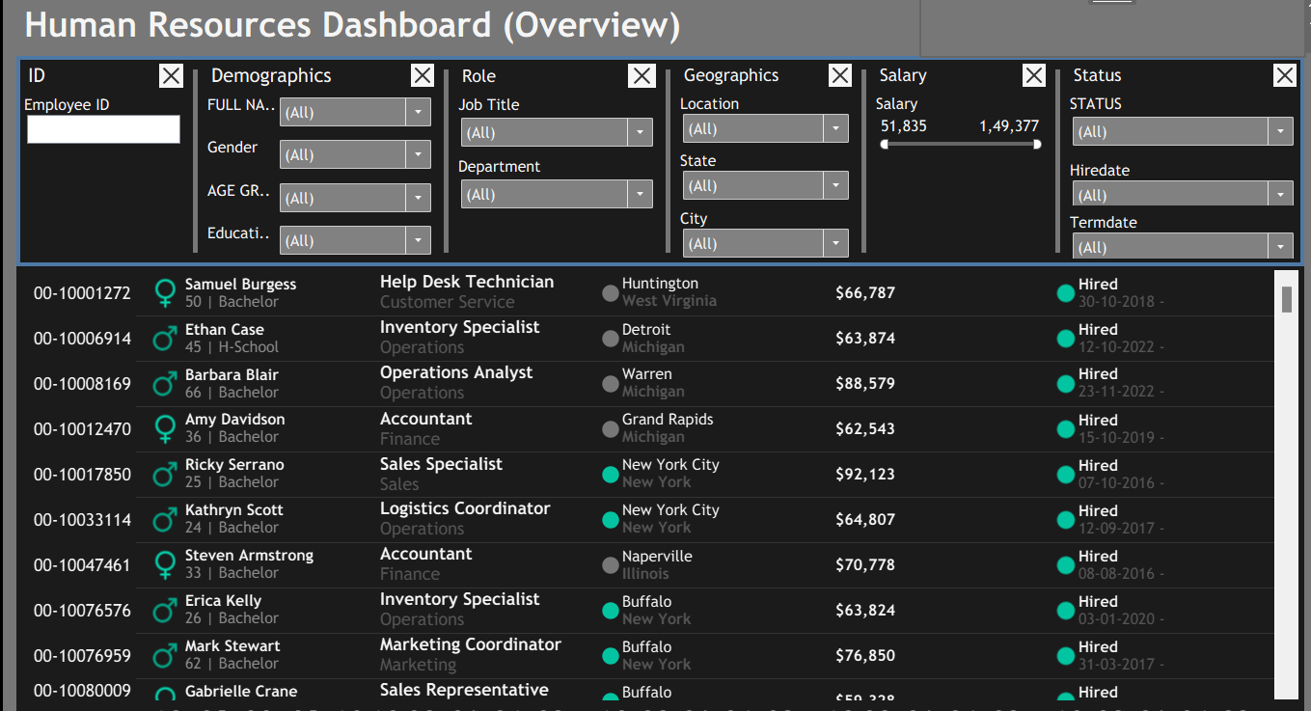

This dashboard provides a detailed, filterable list of all employees, including name, age, gender, education, role, department, location, salary, and status.  
Powerful filters let users quickly segment by demographics, job role, geography, salary range, and employment status.  
This enables efficient searches for specific employee groups (e.g., recent hires, high earners, particular departments or locations), supporting targeted HR analytics and data-driven decisions.

## RECOMMENDATIONS

Based on the analysis and insights from the HR dashboards, the following actions are recommended:

* Focus recruitment on departments and locations with the highest vacancies or turnover to maintain optimal staffing levels.
* Promote gender pay equity and career progression by regularly reviewing compensation and advancement opportunities across educational levels and genders.
* Use demographic and performance data to identify skill gaps and implement targeted training programs for underperforming groups or departments.
* Periodically assess salaries and benefits to remain competitive, especially for critical roles and high performers.
* Keep the dashboards updated to support timely, data-driven workforce planning and improve overall organizational agility.